**Class Diagram**

**GreatOutdoors.Entities**:

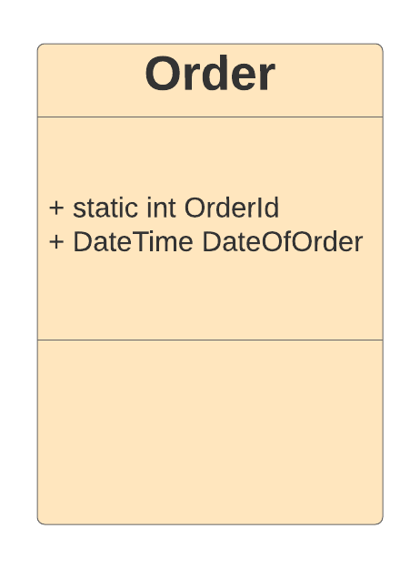

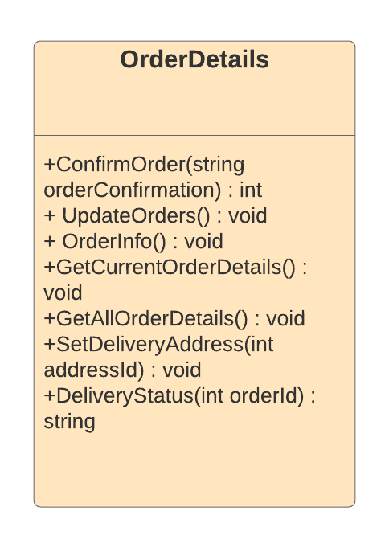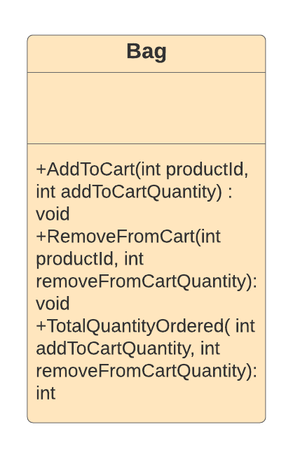**GreatOutdoors.DataAccessLayer:**

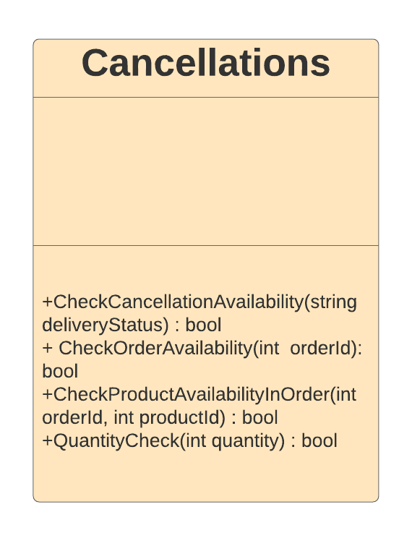**GreatOutdoors.BusinessAccessLayer**: